Human-Adjudicated Semantic Alignment of Critical-Infrastructure Cybersecurity Requirements: TSA Pipeline Directives, CPG 2.0, CSF 2.0, and NERC CIP
Friday Ogochukwu Ikwuogu
Independent Researcher, Odessa, Texas, USA
ORCID: 0009-0009-2222-1318 | Corresponding author email: Friday.ikwuogu@gmail.com
Target venue: International Journal of Critical Infrastructure Protection (Elsevier). Alternate/co-target: Computers & Security.

Abstract
Operators of critical infrastructure increasingly answer to multiple, independently drafted cybersecurity regimes at once. This paper reports a human-adjudicated semantic crosswalk of four U.S. frameworks bearing on pipeline and cross-sector operational technology: the Transportation Security Administration's (TSA) pipeline cybersecurity requirements, the Cybersecurity and Infrastructure Security Agency's (CISA) Cross-Sector Cybersecurity Performance Goals (CPG), the National Institute of Standards and Technology's Cybersecurity Framework (CSF) 2.0, and the North American Electric Reliability Corporation's Critical Infrastructure Protection (NERC CIP) standards. Using NIST CSF 2.0's 22 categories as a common reference taxonomy, we mapped 40 CPG goals, 17 NERC CIP standard-level requirements, and 11 TSA public-record obligations (90 rows in total) and adjudicated each category as Reinforcing, Partially aligned, a Gap, or a Conflict. We find 2 categories of strong three-framework reinforcement, 10 of partial alignment, 9 outright gaps, and one direct Conflict: NERC CIP's 1-hour incident-notification clock, TSA's currently effective 24-hour clock, and CPG's non-mandatory reporting goal point jointly regulated operators toward three different timers and reporting destinations for what may be the same event. Because TSA's own pipeline cybersecurity rule remains in proposed form, several Partial-alignment findings are contingent on that rulemaking's outcome. We name every scope limitation this analysis relies on, including the use of public proxies for Sensitive-Security-Information-designated TSA directive text, and provide the full crosswalk, adjudication rationale, and reproduction pipeline as an open, versioned dataset.
Keywords: critical infrastructure cybersecurity; regulatory crosswalk; TSA pipeline security; NIST CSF 2.0; CISA Cybersecurity Performance Goals; NERC CIP; semantic alignment; OT security governance; regulatory harmonization.

1. Introduction
Pipeline and electric-grid operators in the United States sit at the intersection of several cybersecurity regimes that were drafted by different agencies, on different timelines, for different legal purposes. A pipeline compressor station co-located with, or electrically interconnected to, bulk electric system facilities can be simultaneously subject to TSA's pipeline-specific security directives, CISA's voluntary but increasingly reference-cited Cross-Sector Cybersecurity Performance Goals, and NERC's mandatory, enforceable Critical Infrastructure Protection standards -- while NIST's Cybersecurity Framework sits above all three as the vocabulary each regime borrows from to varying degrees.
The Congressional Research Service has already documented that three Department of Homeland Security cybersecurity reporting rules (TSA, CISA's CIRCIA, and the U.S. Coast Guard's maritime rule) impose materially different incident-reporting clocks and destinations on overlapping populations of regulated entities, and has recommended congressional options ranging from a single statutory reporting definition to a unified federal reporting portal (Congressional Research Service, R49009). That analysis, by its own scope, does not address NERC CIP or the electric sector at all. This paper extends the same style of analysis to a four-framework comparison that does include NERC CIP, and does so at the level of a systematic, category-by-category, human-adjudicated crosswalk rather than a narrative survey.
Our contribution is threefold. First, we build a reproducible crosswalk that places every discrete requirement we could source publicly from TSA, CPG, and NERC CIP onto NIST CSF 2.0's category taxonomy. Second, we adjudicate each of the resulting 22 category cells as Reinforcing, Partially aligned, a Gap, or a Conflict, and we show that this adjudication is internally consistent with the underlying data by construction (Section 3.5). Third, we surface one specific, currently live regulatory conflict -- incident-reporting timelines -- and a cluster of shared blind spots across all three regulatory frameworks, with concrete implications for operators and for the harmonization debate CRS has already opened.
Section 2 describes the four frameworks and related harmonization literature. Section 3 details the crosswalk methodology, taxonomy choice, and every scope limitation we rely on. Section 4 presents the adjudicated results. Section 5 discusses implications. Section 6 states limitations explicitly, and Section 7 concludes.

2. Background and related work

2.1 The four frameworks
NIST CSF 2.0 (February 2024) organizes cybersecurity outcomes into six Functions -- Govern, Identify, Protect, Detect, Respond, Recover -- and 22 Categories beneath them; it is voluntary and sector-agnostic, and is explicitly designed as a common reference vocabulary (NIST, 2024).
CISA's Cross-Sector Cybersecurity Performance Goals are a voluntary, prioritized subset of cybersecurity practices for critical infrastructure of any sector. This paper's crosswalk uses CPG version 1.0.1's verified 33-goal list as its evidentiary base (CISA, n.d.); CISA released CPG 2.0 in December 2025, realigning the goals to CSF 2.0's six Functions (adding an explicit Govern function), consolidating prior OT-only goals into unified IT/OT goals, and adding roughly four new third-party-risk and zero-trust goals (CISA, 2025). We were unable to machine-extract CPG 2.0's exact goal-level text during this build (Section 3.6) and flag every affected row accordingly.
NERC CIP is a suite of mandatory, FERC-enforced Reliability Standards binding on owners and operators of the Bulk Electric System. This paper draws on the 13 currently active CIP standards, CIP-002 through CIP-014 (NERC, current versions per standard, accessed via nerc.com and secondary aggregation).
TSA's pipeline cybersecurity requirements are currently imposed through Security Directives issued under emergency authority beginning in 2021; the directive text itself is designated Sensitive Security Information and is not publicly released. TSA has proposed to codify and replace this Security-Directive approach with a formal rule -- "Enhancing Surface Cyber Risk Management" -- first noticed in 2022 (87 FR 75627) and, following a supplemental notice, still in proposed (not final) form as of the most recent public record available to this study (89 FR 88488; comment period closed February 5, 2025).

2.2 Related work on harmonization
CRS (R49009) is the closest prior work: it documents that TSA (24-hour reporting), CISA's CIRCIA rule (72-hour reporting; 24-hour for ransomware payments), and the U.S. Coast Guard ("without delay") impose different clocks and different reporting destinations on overlapping regulated populations, and that industry commenters and GAO have both suggested NIST CSF as a common definitional baseline for harmonization. GAO (GAO-25-107947) separately evaluates TSA's surface-transportation cybersecurity program and documents the content of the currently effective pipeline Security Directives (coordinator designation, 24-hour incident reporting, vulnerability assessments, ransomware mitigation actions, contingency/recovery plans, and architecture design review) as part of an oversight assessment, which this paper uses as its public-record proxy for that non-public directive text. Neither prior work incorporates NERC CIP into a like-for-like comparison; this paper's four-framework, category-level crosswalk is intended to close that specific gap.

3. Methods

3.1 Scope and unit of analysis
The unit of analysis is the discrete requirement statement, at each framework's own natural top operational grain given public-source availability: NERC CIP at standard level (occasionally split into two-to-four rows per standard where a single standard visibly bundles distinct obligations, e.g., CIP-007 splits into patch management, malicious-code prevention, event logging, and authentication), CPG at individual-goal level, and TSA at the obligation level documented in the public sources named in Section 2.1. This produced 40 CPG rows, 17 NERC CIP rows, and 11 TSA rows (90 total crosswalk rows, including the 22 CSF 2.0 category reference rows).

3.2 Taxonomy
We use NIST CSF 2.0's Function/Category structure as the crosswalk's backbone rather than building a bespoke taxonomy inductively, for two reasons specific to this domain: CSF 2.0 is already the field's most widely adopted cross-sector reference vocabulary (Section 2.2), and CISA's own CPG 2.0 update independently converged on the same six-Function structure while this project was underway, which we take as external validation of the taxonomy choice rather than a coincidence to route around.

3.3 Mapping procedure
Every non-CSF row was assigned to its single nearest CSF 2.0 category by the author, working from each source's own stated title and text, and tagged with a confidence level: high (53 rows), medium (13 rows, a genuine either-of-two-categories judgment call), or LOW (2 rows, the CPG 2.0 placeholders described in Section 3.6). This was an AI-assisted first pass; every medium- and LOW-confidence row was subsequently reviewed and signed off by the author on 2026-09-19 (docs/VERIFY_CHECKLIST.md), including the marquee RS.CO conflict claim in Section 4.2.

3.4 Adjudication
Within each of the 22 CSF 2.0 categories, the author adjudicated the relationship among whichever of the three regulatory/voluntary frameworks (CPG, NERC CIP, TSA) had at least one mapped requirement there, assigning one of four verdicts. Reinforce = frameworks impose materially the same obligation; Partial = same topic, different strength/scope/enforceability; Gap = one or more frameworks silent where another imposes a duty; Conflict = requirements point operators in different directions. The full rationale for every category is reported in Section 4 and the supplement (data/processed/adjudication.csv).

3.5 Data quality and reproducibility
The pipeline is fully scripted and numbered (code/01_fetch.py through code/05_manuscript.js) and re-derives every output from the raw source files in data/raw/. A programmatic cross-check compares the author's adjudicated "frameworks present" claim for each category against what the crosswalk data actually contains, and refuses to proceed on any mismatch; this check passed with zero mismatches on the version reported here (qa_mismatches = 0 per data/processed/qa_report.txt). Every number in this manuscript is interpolated from paper/stats.json, which the QA script writes; no number here was typed independently of that file.

3.6 Named scope limitations
Two scope limitations affect this crosswalk's TSA and CPG content specifically, and both are treated as first-class findings rather than footnotes:
(a) TSA source text. The Security Directives that currently bind pipeline operators (Pipeline-2021-02 series) are designated Sensitive Security Information and are not publicly released. This study uses only public-record characterizations of that content -- principally GAO's own public oversight summary (GAO-25-107947) -- plus the publicly available text of TSA's proposed rule for the (not yet binding) requirements it would newly codify. Every TSA row in the crosswalk is labeled with its actual legal status ("currently effective (SD)" or "proposed (NPRM, not final)") so that no reader can mistake a proposed requirement for a binding one.
(b) CPG 2.0 source text. CISA's primary CPG 2.0 document (published December 11, 2025) returned an HTTP 403 response to every automated retrieval attempt made during this build (a web-application-firewall block, not a licensing or access restriction). This crosswalk's CPG rows therefore use the previously verified CPG 1.0.1 goal list, annotated wherever three independent secondary accounts of the CPG 2.0 release confirm a specific structural change (a new Govern-function goal set; consolidation of prior OT-only goals into unified goals; roughly four new third-party/zero-trust goals). 2 rows are explicit placeholders (row status UNRESOLVED_SOURCE_BLOCKED); the author reviewed this limitation on 2026-09-19 and elected to retain these rows as documented rather than reconcile them against unconfirmed text, deferring reconciliation of the primary CPG 2.0 PDF to v0.2 (docs/NEXT_STEPS.md). This decision changes no verdict and no agreement statistic reported in Section 4.

4. Results
Across the 22 CSF 2.0 categories, 2 (9.1%) show strong three-framework reinforcement, 10 show partial alignment, 9 are outright gaps (no framework, or only one, addresses that category), and 1 is a direct conflict -- together, 45.5% of categories carry an unresolved gap or conflict an operator would have to resolve unassisted. Figure 1 shows every category's verdict alongside which of the three frameworks contributes to it; Figure 2 shows category coverage by framework within each Function; Figure 3 summarizes verdict counts by Function.
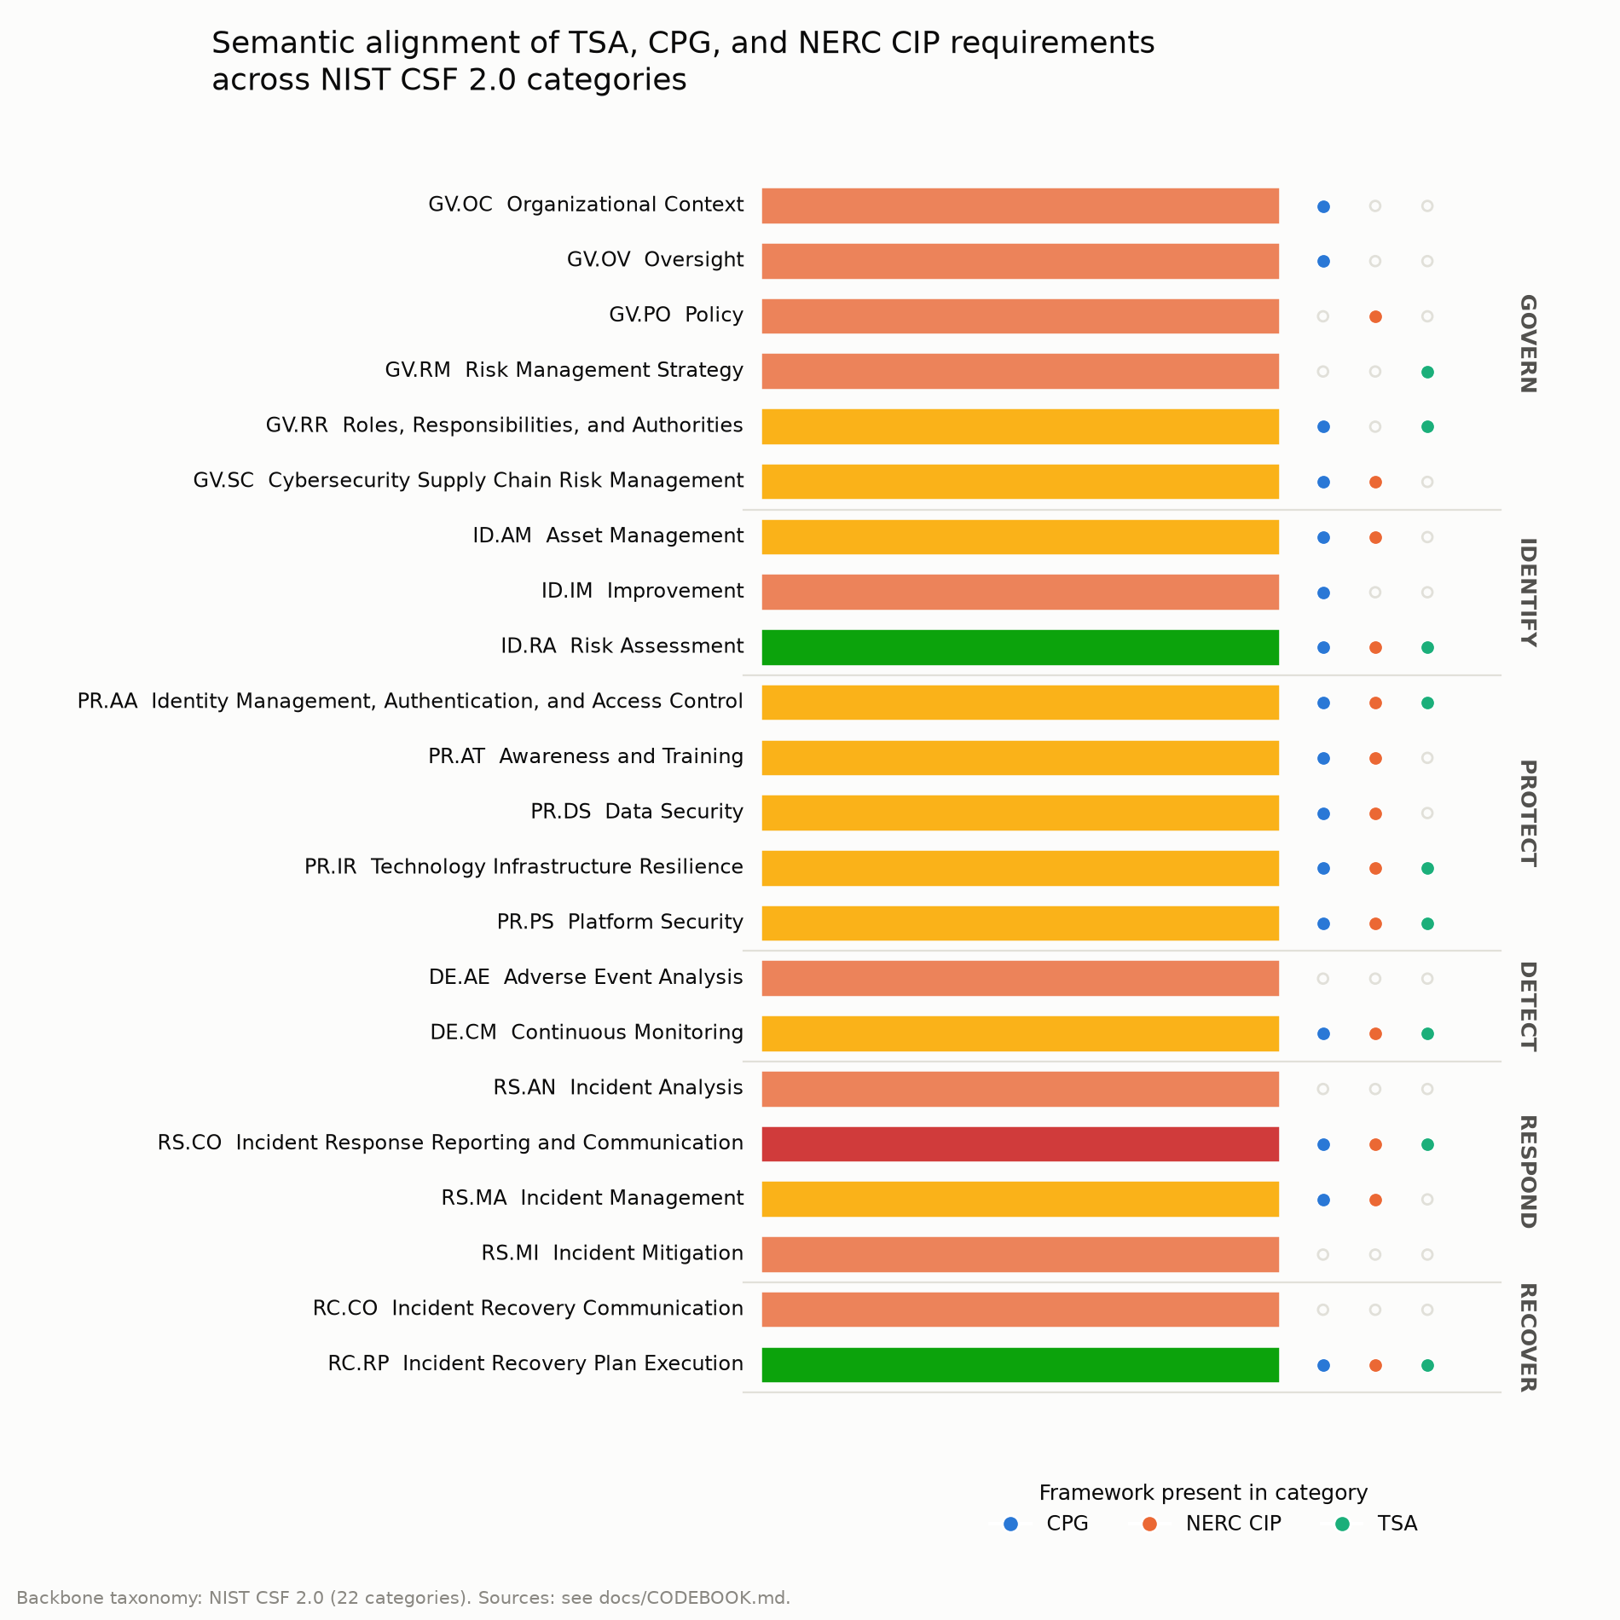
Figure 1. Adjudicated alignment verdict for each of NIST CSF 2.0's 22 categories, grouped by Function, with markers showing which of CPG, NERC CIP, and TSA have at least one mapped requirement in that category.
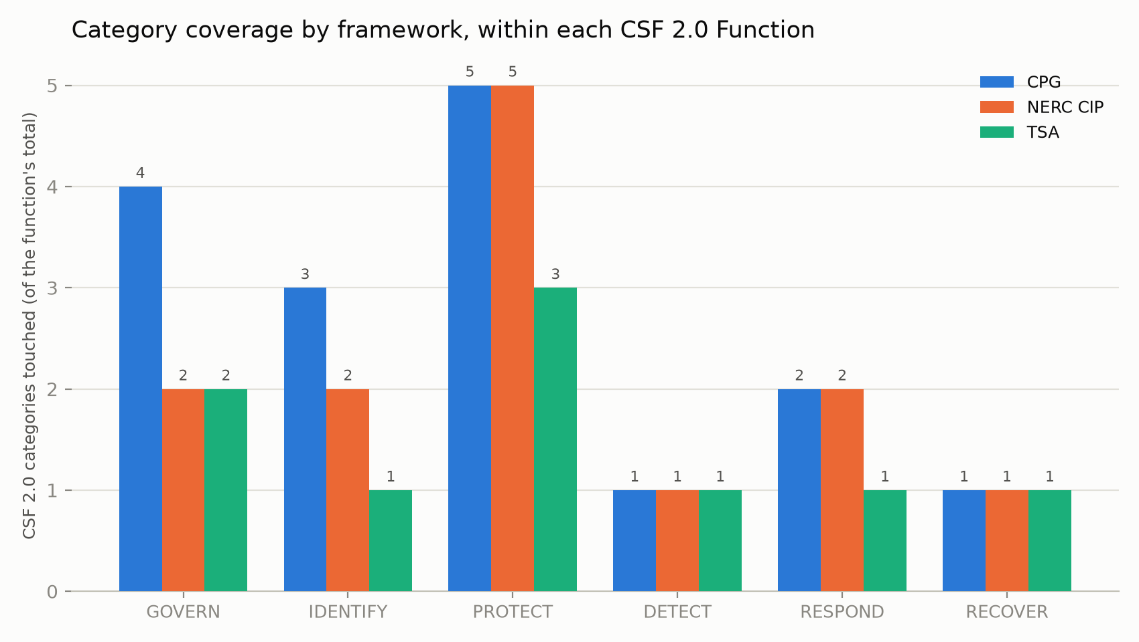
Figure 2. Number of CSF 2.0 categories, within each Function, touched by each framework.
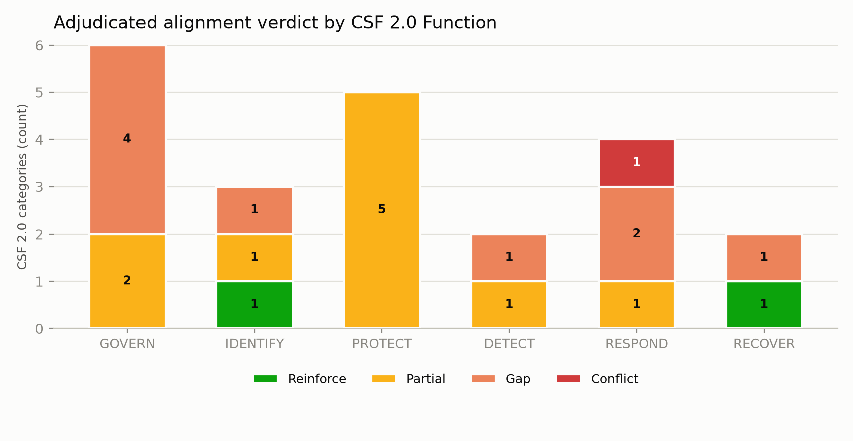
Figure 3. Count of Reinforce / Partial / Gap / Conflict verdicts by CSF 2.0 Function.

4.1 The strongest alignments
Two categories show clean, three-way reinforcement: Risk Assessment (ID.RA) -- CPG's known-vulnerability-mitigation goal, NERC CIP-010's periodic vulnerability assessments and CIP-014's substation risk assessment, and TSA's currently effective vulnerability-assessment and architecture-design-review requirements all converge on the same obligation -- and Incident Recovery Plan Execution (RC.RP), where CPG, NERC CIP-009, and TSA's currently effective contingency/recovery-plan requirement not only agree in substance but are all three already binding today, independent of TSA's pending rulemaking.

4.2 The marquee conflict: incident-reporting timelines (RS.CO)
All three frameworks require incident reporting, but with materially different clocks and destinations. NERC CIP-008 requires notification to E-ISAC/NCCIC within 1 hour of determining a Reportable Cyber Security Incident (end of next calendar day (variable, not a fixed hour count) for an attempted compromise); the currently effective TSA Security Directive requires notification to CISA within 24 hours; CPG's reporting goal sets no fixed mandatory clock at all. Unlike several Partial-alignment findings elsewhere in this crosswalk, this conflict does not depend on TSA's rule being finalized -- the NERC and TSA clocks are both already binding, so the misalignment exists today for any operator jointly touched by both regimes. This finding parallels CRS's independently documented conflict among TSA, CIRCIA, and Coast Guard reporting rules, extending it to show that NERC CIP's clock is tighter still, and that NERC CIP has not previously been part of that comparison.

4.3 Shared blind spots
Four categories are gaps because none of the three frameworks addresses them at all: Adverse Event Analysis (DE.AE), Incident Analysis (RS.AN), Incident Mitigation (RS.MI), and Incident Recovery Communication (RC.CO). Read together, these four gaps trace a consistent pattern: every framework studied here asks operators to monitor (DE.CM), to report (RS.CO), and to recover (RC.RP), but none imposes a distinct, named obligation to analyze what was detected, to actively mitigate an incident in progress, or to communicate with stakeholders specifically during recovery, as opposed to at first report. This is a shared design gap across the regulatory landscape, not a shortcoming of any one framework.

4.4 Partial alignments driven by TSA's pending rulemaking
A distinct pattern recurs in Identity Management/Access Control (PR.AA), Platform Security (PR.PS), Technology Infrastructure Resilience (PR.IR), and Continuous Monitoring (DE.CM): CPG and NERC CIP already impose specific, currently binding requirements, and TSA's proposed rule would impose a matching requirement -- but only the proposed rule does so; TSA's currently effective Security Directives are comparatively general on these specific points. These four categories are best read as reinforcing in intent but partial in current enforceability, and are the categories most likely to move from Partial to Reinforce if and when TSA's rule is finalized substantially as proposed.

5. Discussion
For operators. An operator subject to both NERC CIP and TSA pipeline requirements should not treat either clock as sufficient on its own: the practical action implied by Section 4.2 is to build incident-notification procedures around the tightest applicable clock (currently NERC CIP's one hour) and to maintain parallel, pre-drafted notification templates for each required destination, rather than assuming a single report satisfies every regime. More broadly, the crosswalk in Figure 1 and the supplement can serve as a checklist: an operator can locate any given internal control by its CSF 2.0 category and see at a glance which external regimes already require it, which only propose to, and which are silent.
For policy. This paper's evidence directly supports extending CRS's harmonization analysis (R49009) to include NERC CIP: the reporting-timeline conflict identified here is at least as concrete as the DHS-internal conflicts CRS already documents, and it is live today rather than contingent on a future rulemaking. The shared blind-spot cluster (Section 4.3) is a second, independent argument for cross-agency coordination: if CISA, TSA, and NERC each separately expand their own frameworks to cover incident analysis, in-progress mitigation, and recovery communication, operators will likely face a second wave of the same kind of divergence documented here for reporting, unless that expansion is coordinated around the shared CSF 2.0 vocabulary from the outset.
For future work. Because several findings in this crosswalk are contingent on TSA's pending rule, we recommend re-running this pipeline (which is fully scripted and versioned) once a final rule publishes, and separately once the author has reconciled the CPG 2.0 placeholder rows against CISA's primary document (Section 3.6). Both are named next steps in docs/NEXT_STEPS.md.

6. Limitations
This study has the following named limitations, in addition to those detailed in Section 3.6:
1. Category-level, not subcategory-level, CSF 2.0 mapping. CSF 2.0 defines 106 subcategories beneath its 22 categories; this crosswalk maps to the category level for tractability. A subcategory-level crosswalk would likely surface additional, finer-grained partial alignments and gaps not visible here.
2. NERC CIP at standard level, not full sub-requirement (R-part) level. Several standards (e.g., CIP-003, CIP-010) bundle additional obligations beyond what is captured in this crosswalk's rows for them.
3. Single-author adjudication. Every verdict in Section 4 was adjudicated by one author. Inter-rater reliability with a second independent adjudicator has not been established for this version.
4. Point-in-time accuracy. TSA's rulemaking status, CPG's version, and NERC CIP's active standard versions are all current as of this manuscript's build date and are subject to change before or during peer review; Section 3.6 names the specific reconfirmation steps required before submission.
5. No claim of legal completeness. This crosswalk is a semantic-alignment research instrument, not a compliance determination; it should not be relied upon by any operator as a substitute for its own regulatory counsel's analysis of applicable obligations.

7. Conclusion
A category-level, human-adjudicated crosswalk of TSA, CPG, CSF 2.0, and NERC CIP finds real reinforcement in core risk-assessment and recovery-planning obligations, but also finds 45.5% of CSF 2.0 categories carrying an unresolved gap or conflict -- most notably a live, already-binding conflict in incident-reporting timelines that CRS's prior DHS-focused harmonization analysis did not have occasion to examine. We release the full crosswalk, adjudication rationale, and reproduction pipeline openly so that operators, regulators, and future researchers can extend, contest, or update these findings as the frameworks themselves continue to evolve.

Data and code availability
The complete crosswalk (data/processed/crosswalk.csv), adjudication table (data/processed/adjudication.csv), QA report, figures, and the numbered pipeline that reproduces them from raw source records are released under CC BY 4.0 (data/documents) and MIT (code) at the project's GitHub repository and archived with Zenodo DOI https://doi.org/10.5281/zenodo.22852102.

Declaration of AI assistance
AI assistance (Anthropic Claude, via the Claude Agent SDK) was used for source retrieval, first-pass category mapping, figure generation, and manuscript drafting under this project's build pipeline. The author made every adjudication verdict, reviewed and edited all AI-assisted drafting, and takes full responsibility for the accuracy of every claim in this manuscript.

Declaration of competing interests
The author declares no competing financial or personal interests that could have influenced the work reported in this paper.

References
Cybersecurity and Infrastructure Security Agency (CISA). (n.d.). Cross-Sector Cybersecurity Performance Goals (CPG), version 1.0.1. https://www.cisa.gov/cross-sector-cybersecurity-performance-goals-cpgs
Cybersecurity and Infrastructure Security Agency (CISA). (2025, December 11). Cybersecurity Performance Goals 2.0 for Critical Infrastructure. https://www.cisa.gov/news-events/alerts/2025/12/11/cybersecurity-performance-goals-20-critical-infrastructure
Government Accountability Office (GAO). (2025). Surface Transportation: TSA Is Taking Steps to Enhance Cybersecurity, but Additional Actions Are Needed (GAO-25-107947). https://files.gao.gov/reports/GAO-25-107947/index.html
National Institute of Standards and Technology (NIST). (2024). The NIST Cybersecurity Framework (CSF) 2.0 (NIST CSWP 29). https://nvlpubs.nist.gov/nistpubs/CSWP/NIST.CSWP.29.pdf
North American Electric Reliability Corporation (NERC). Critical Infrastructure Protection (CIP) Reliability Standards, CIP-002 through CIP-014 (current versions). https://www.nerc.com/standards/
Transportation Security Administration (TSA). (2022, November 30). Enhancing Surface Cyber Risk Management; Notice of proposed rulemaking. 87 FR 75627. https://www.federalregister.gov/documents/2022/11/30/2022-25941/enhancing-surface-cyber-risk-management
Transportation Security Administration (TSA). (2024, November 7). Enhancing Surface Cyber Risk Management; Supplemental notice of proposed rulemaking. 89 FR 88488. https://www.federalregister.gov/documents/2024/11/07/2024-24704/enhancing-surface-cyber-risk-management
Congressional Research Service (CRS). Cybersecurity: Considerations on Regulatory Harmonization (R49009). https://www.everycrsreport.com/reports/R49009.html

